Perform a SQL Query — Devices & Login Activity

Overview
This task required retrieving information with SELECT/FROM and organizing results with ORDER BY. The main objectives were:
- Inspect employee device data to identify update needs
- Investigate login activity for potential anomalies
- Order and review login attempts chronologically
Why this matters (Security Analyst context): Querying and sorting data quickly is essential for triage, incident investigation, and audit readiness.

Scenario
The task was to determine which employee devices must be updated and check user login activity for anything unusual. All data resided in the organization database, tables machines and log_in_attempts.

Task 1 — Retrieve employee device data

1) Return all device information

SELECT *
FROM machines;

The output returns all the contents of the machines table:
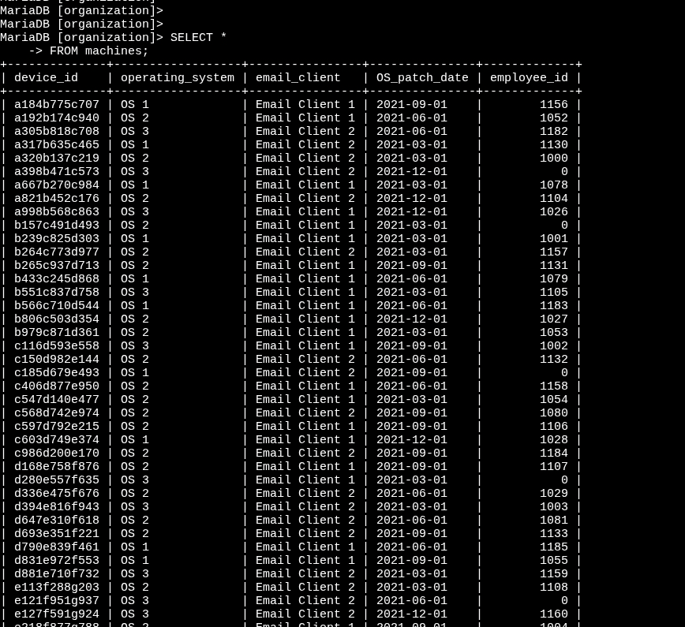

2) Focus on email client per device

SELECT device_id, email_client
FROM machines;

The output should return only the selected columns of the machines table:
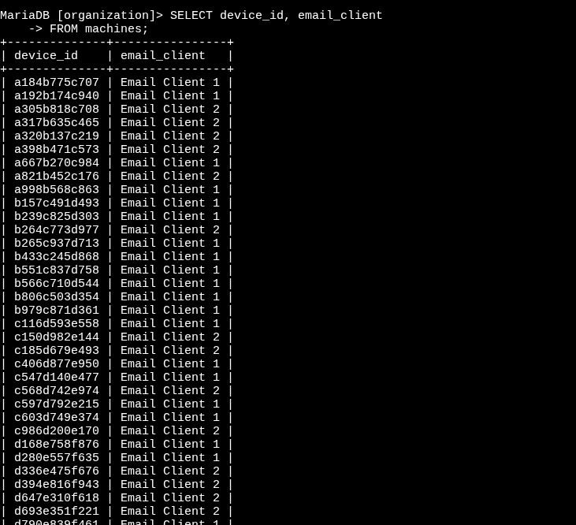

Determine the email client returned in the third row.
Result: The email client in the 3rd row was Email Client 2.

3) Show OS and last patch date

SELECT device_id, operating_system, OS_patch_date
FROM machines;

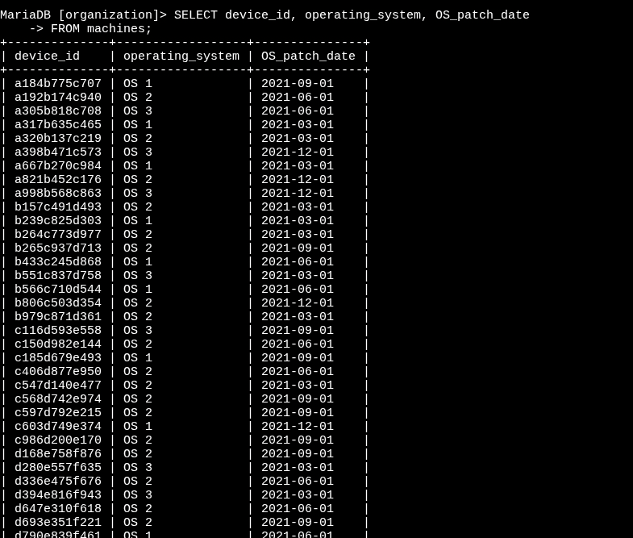
Determine the patch date of the first entry.
Result: Patch date of the first entry was 2021-09-01.

Task 2 — Investigate login activity

1) Countries of login attempts

SELECT event_id, country
FROM log_in_attempts;

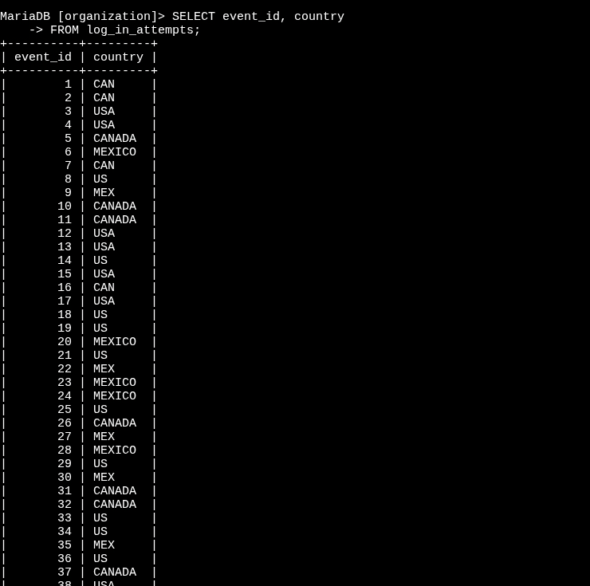Determine if any login attempts were made from Australia.
Result: No attempts from Australia.
2) Review username, date, time
SELECT username, login_date, login_time
FROM log_in_attempts;
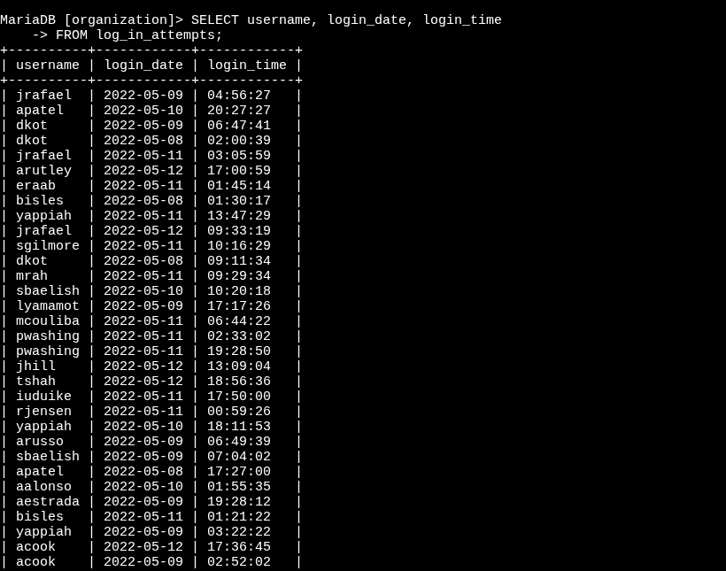
Determine the username from the fifth row.
Result: Username in the 5th row was jrafael.

3) Get a complete picture (all columns)

SELECT *
FROM log_in_attempts;
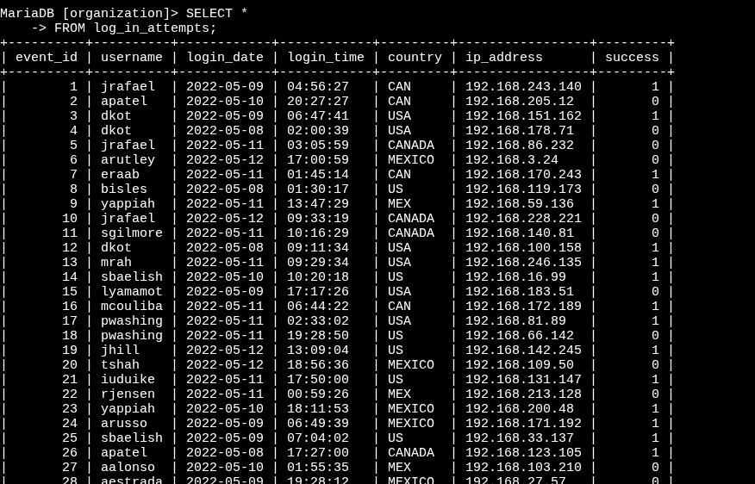

Task 3 — Order login attempts data

1) Order by date (ascending)

SELECT *
FROM log_in_attempts
ORDER BY login_date;
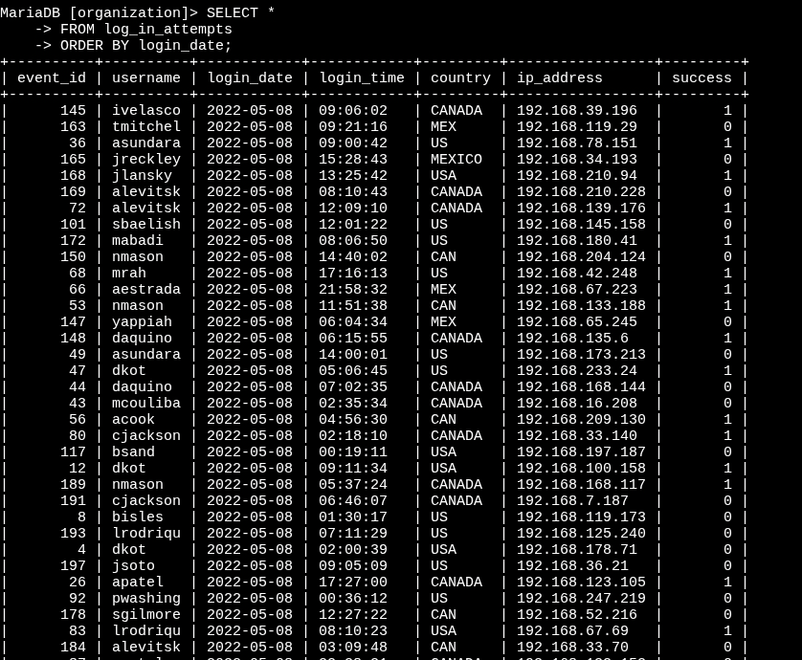Extract the username and login date from the first record.
Result: First record returned → ivelasco on 2022-05-08.

2) Order by date and time (ascending)

SELECT *
FROM log_in_attempts
ORDER BY login_date, login_time;
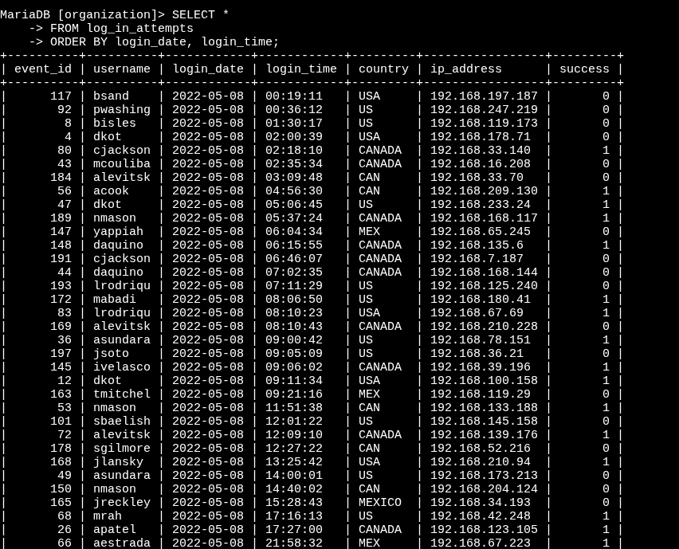
Extract the username and login time from the first record.
Result: First record returned → bsand at 00:19:11.

Results & Findings (Knowledge‑check answers)
- Email client in 3rd row: Email Client 2
- Patch date of 1st entry: 2021‑09‑01
- Any attempts from Australia?: No
- Username in 5th row: jrafael
- Earliest record by date: ivelasco on 2022‑05‑08
- Earliest record by date & time: bsand at 00:19:11

Skills Demonstrated
- Column selection with SELECT (targeted retrieval)
- Full‑table retrieval with SELECT *
- Sorting results with ORDER BY (single and multi‑column)
- Practical checks for geolocation and off‑hours activity

